**CHAPTER 1: Cosmology and the Birth of the Earth**

**MULTIPLE CHOICE**

1. The branch of science that studies the structure and history of the Universe is

|  |  |  |  |
| --- | --- | --- | --- |
| a. | cosmetology. | c. | cosmology. |
| b. | scientology. | d. | astrology. |

ANS: C DIF: Easy REF: 1.1

OBJ: 1A. Assess how people’s perceptions of the Earth’s place in the Universe have changed over the centuries. MSC: Remembering

2. __________ is the substance that makes up objects.

|  |  |
| --- | --- |
| a. | Energy |
| b. | Mass |
| c. | Matter |
| d. | Cosmology |

ANS: C DIF: Easy REF: 1.1

OBJ: 1D. Describe where the elements that make up matter came from.

MSC: Remembering

3. The amount of matter in an object is referred to as its

|  |  |
| --- | --- |
| a. | cosmology. |
| b. | astrology. |
| c. | weight. |
| d. | mass. |

ANS: D DIF: Easy REF: 1.1

OBJ: 1D. Describe where the elements that make up matter came from.

MSC: Remembering

4. Energy can best be described as

|  |  |
| --- | --- |
| a. | the substance that makes up objects. |
| b. | the inherent ability of a region of space and the matter within it to do work. |
| c. | the amount of matter in an object. |
| d. | the change in frequency that happens when a wave source moves. |

ANS: B DIF: Moderate REF: 1.1

OBJ: 1D. Describe where the elements that make up matter came from.

MSC: Understanding

5. In the context of scientific cosmology, the universe contains two basic entities: __________ and __________.

|  |  |
| --- | --- |
| a. | matter, energy |
| b. | mass, energy |
| c. | stars, planets |
| d. | celestial objects, matter |

ANS: A DIF: Easy REF: 1.1

OBJ: 1D. Describe where the elements that make up matter came from.

MSC: Understanding

6. In the heliocentricmodel,

|  |  |
| --- | --- |
| a. | the Earth orbits around the Sun. |
| b. | the Sun orbits around the Earth. |
| c. | the Earth is a stationary planet. |
| d. | Mercury and Venus orbit around the Sun, but all other planets orbit around the Earth. |

ANS: A DIF: Easy REF: 1.2

OBJ: 1A. Assess how people’s perceptions of the Earth’s place in the Universe have changed over the centuries. MSC: Remembering

7. Which of the following is NOT necessarily true of a planet?

|  |  |
| --- | --- |
| a. | It orbits a star. |
| b. | It is nearly spherical in shape. |
| c. | It has one or more moons. |
| d. | It has cleared its neighborhood of other objects. |

ANS: C DIF: Moderate REF: 1.2

OBJ: 1A. Assess how people’s perceptions of the Earth’s place in the Universe have changed over the centuries. | 1B. Explain modern concepts concerning the basic architecture of our Universe and its components. MSC: Analyzing

8. Eratosthenes was the first person to accurately estimate the size of the Earth. He accomplished this feat by

|  |  |
| --- | --- |
| a. | sailing around the world and estimating his average rate of travel. |
| b. | comparing the length of an Earth day with the distance between the Earth and the Sun. |
| c. | measuring the severity of the greatest earthquakes. |
| d. | observing shadows cast simultaneously at two different cities that were separated by a known distance. |

ANS: D DIF: Easy REF: 1.2

OBJ: 1A. Assess how people’s perceptions of the Earth’s place in the Universe have changed over the centuries. MSC: Applying

9. In ancient Greece, Eratosthenes measured the difference in angles of the Sun’s rays in two different locations in Egypt at the same time to calculate the

|  |  |
| --- | --- |
| a. | rate of rotation of the Earth. |
| b. | distance from the Earth to the Moon. |
| c. | distance from the Earth to the Sun. |
| d. | circumference of the Earth. |

ANS: D DIF: Easy REF: 1.2

OBJ: 1A. Assess how people’s perceptions of the Earth’s place in the Universe have changed over the centuries. MSC: Understanding

10. Aside from the Earth, the terrestrial planets are

|  |  |
| --- | --- |
| a. | Mars, Mercury, and Venus. |
| b. | Mars, Venus, and Jupiter. |
| c. | Jupiter, Saturn, Uranus, and Neptune. |
| d. | Mars and Saturn. |

ANS: A DIF: Easy REF: 1.2

OBJ: 1B. Explain modern concepts concerning the basic architecture of our Universe and its components. MSC: Remembering

11. Which of the following is a terrestrial planet?

|  |  |
| --- | --- |
| a. | Neptune |
| b. | Mercury |
| c. | Jupiter |
| d. | Uranus |

ANS: B DIF: Moderate REF: 1.2

OBJ: 1B. Explain modern concepts concerning the basic architecture of our Universe and its components. MSC: Understanding

12. The giant planets are

|  |  |
| --- | --- |
| a. | Mars, Mercury, and Venus. |
| b. | Mars, Venus, and Jupiter. |
| c. | Jupiter, Saturn, Uranus, and Neptune. |
| d. | Uranus, Saturn, and Neptune. |

ANS: C DIF: Easy REF: 1.2

OBJ: 1B. Explain modern concepts concerning the basic architecture of our Universe and its components. MSC: Remembering

13. The terrestrial planets are also known as the

|  |  |
| --- | --- |
| a. | inner planets. |
| b. | outer planets. |
| c. | giant planets. |
| d. | Jovian planets. |

ANS: A DIF: Moderate REF: 1.2

OBJ: 1B. Explain modern concepts concerning the basic architecture of our Universe and its components. MSC: Understanding

14. Terrestrial planets are mainly composed of ________, while the giant planets are made predominantly of ________.

|  |  |
| --- | --- |
| a. | volatiles; rock and metals |
| b. | rock and metals; volatiles |
| c. | refractory materials; volatiles and metals |
| d. | volatiles and metals; refractory materials |

ANS: B DIF: Difficult REF: 1.2

OBJ: 1B. Explain modern concepts concerning the basic architecture of our Universe and its components. MSC: Applying

15. Which of the following statements is true of terrestrial planets as compared to the Jovian planets?

|  |  |
| --- | --- |
| a. | Terrestrial planets are smaller. |
| b. | Terrestrial planets are less dense. |
| c. | Terrestrial planets are farther from the Sun. |
| d. | Terrestrial planets have higher masses. |

ANS: A DIF: Difficult REF: 1.2

OBJ: 1B. Explain modern concepts concerning the basic architecture of our Universe and its components. MSC: Analyzing

16. Which of the following planets is MOST similar to Earth?

|  |  |
| --- | --- |
| a. | Neptune |
| b. | Mercury |
| c. | Jupiter |
| d. | Uranus |

ANS: B DIF: Moderate REF: 1.2

OBJ: 1B. Explain modern concepts concerning the basic architecture of our Universe and its components. MSC: Analyzing

17. Which planet in our Solar System has the highest mass?

|  |  |
| --- | --- |
| a. | Earth |
| b. | Mars |
| c. | Jupiter |
| d. | Neptune |

ANS: C DIF: Moderate REF: 1.2

OBJ: 1B. Explain modern concepts concerning the basic architecture of our Universe and its components. MSC: Analyzing

18. Most asteroids inhabit the “asteroid belt” between the planets

|  |  |  |  |
| --- | --- | --- | --- |
| a. | Earth and Mars. | c. | Jupiter and Saturn. |
| b. | Mars and Jupiter. | d. | Neptune and Pluto. |

ANS: B DIF: Easy REF: 1.2

OBJ: 1B. Explain modern concepts concerning the basic architecture of our Universe and its components. MSC: Remembering

19. Which of the following is NOT considered a Jovian planet?

|  |  |  |  |
| --- | --- | --- | --- |
| a. | Uranus | c. | Saturn |
| b. | Neptune | d. | Pluto |

ANS: D DIF: Easy REF: 1.2

OBJ: 1B. Explain modern concepts concerning the basic architecture of our Universe and its components. MSC: Understanding

20. Which of the following is most true of moons?

|  |  |
| --- | --- |
| a. | Moons orbit a star. |
| b. | Moons orbit a planet. |
| c. | Moons are stationary in space. |
| d. | Moons are composed of rock. |

ANS: B DIF: Moderate REF: 1.2

OBJ: 1B. Explain modern concepts concerning the basic architecture of our Universe and its components. MSC: Applying

21. A light year is a unit that measures

|  |  |  |  |
| --- | --- | --- | --- |
| a. | time. | c. | distance. |
| b. | mass. | d. | luminous intensity. |

ANS: C DIF: Easy REF: 1.2

OBJ: 1B. Explain modern concepts concerning the basic architecture of our Universe and its components. MSC: Understanding

22. Our Solar System belongs to a galaxy known as

|  |  |  |  |
| --- | --- | --- | --- |
| a. | Andromeda. | c. | the Milky Way. |
| b. | Cepheus. | d. | the Stratosphere. |

ANS: C DIF: Easy REF: 1.2

OBJ: 1B. Explain modern concepts concerning the basic architecture of our Universe and its components. MSC: Remembering

23. The closest galaxy to ours is ________, which is 4.37 light years away.

|  |  |  |  |
| --- | --- | --- | --- |
| a. | Alpha Centauri | c. | Kuiper Belt |
| b. | Andromeda | d. | Orion |

ANS: A DIF: Easy REF: 1.2

OBJ: 1B. Explain modern concepts concerning the basic architecture of our Universe and its components. MSC: Remembering

24. Foucault’s experiment with a pendulum proved that

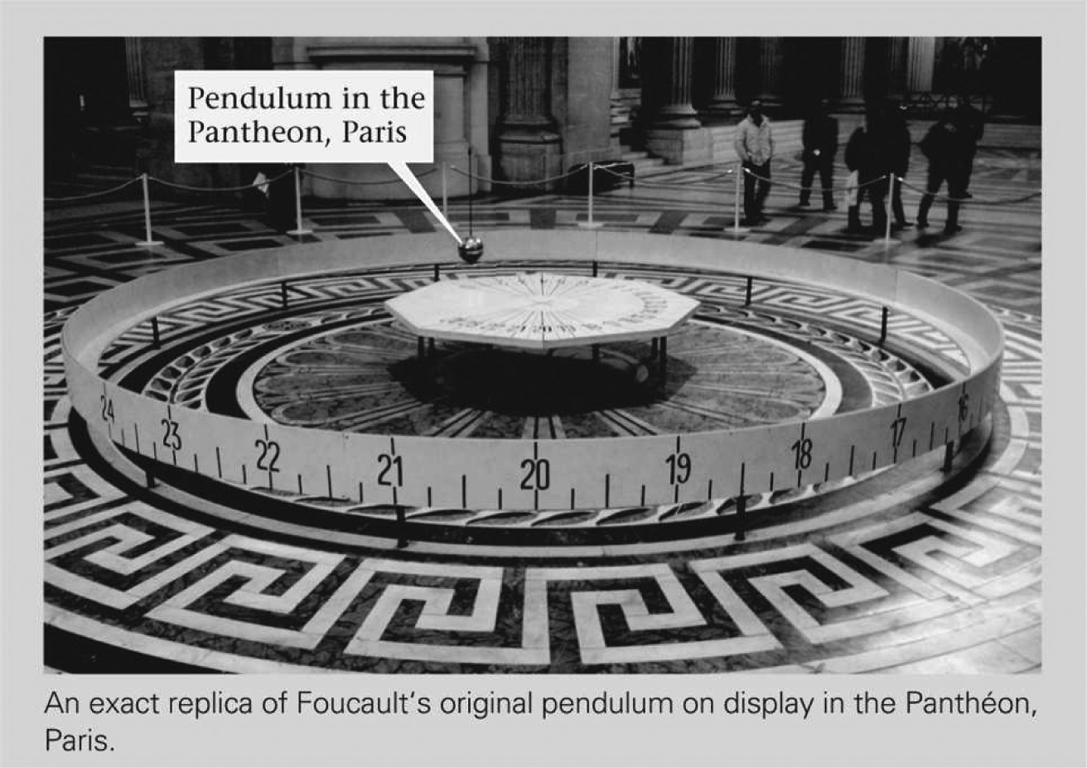

|  |  |
| --- | --- |
| a. | the Earth is the center of the Universe. |
| b. | the Earth revolves around the Sun. |
| c. | the Earth rotates about an internal axis. |
| d. | the Sun revolves around the Earth. |

ANS: C DIF: Moderate REF: 1.2 | Box 1.2

OBJ: 1A. Assess how people’s perceptions of the Earth’s place in the Universe have changed over the centuries. MSC: Applying

25. According to the Big Bang theory,

|  |  |
| --- | --- |
| a. | the Earth is much older than the rest of the Universe. |
| b. | the Universe is much older than the Earth. |
| c. | the Earth and the Universe formed at about the same time. |
| d. | there is no way of knowing how old the Universe might be. |

ANS: B DIF: Moderate REF: 1.3

OBJ: 1B. Explain modern concepts concerning the basic architecture of our Universe and its components. | 1C. Assess the evidence for the expanding Universe and the Big Bang theory.

MSC: Analyzing

26. The best estimate of when the Universe formed is

|  |  |  |  |
| --- | --- | --- | --- |
| a. | 13.7 Ma. | c. | 4.57 Ma. |
| b. | 13.7 Ga. | d. | 4.57 Ga. |

ANS: B DIF: Moderate REF: 1.3

OBJ: 1B. Explain modern concepts concerning the basic architecture of our Universe and its components. | 1C. Assess the evidence for the expanding Universe and the Big Bang theory.

MSC: Remembering

27. Researchers have determined that the Universe began expanding after the Big Bang. When did the Big Bang event occur?

|  |  |  |  |
| --- | --- | --- | --- |
| a. | 1.3 Ga | c. | 137 Ga |
| b. | 13.7 Ga | d. | 13.7 Ma |

ANS: B DIF: Moderate REF: 1.3

OBJ: 1B. Explain modern concepts concerning the basic architecture of our Universe and its components. | 1C. Assess the evidence for the expanding Universe and the Big Bang theory.

MSC: Remembering

28. The Big Bang theory states that

|  |  |
| --- | --- |
| a. | all stars will end their lives explosively as supernovas. |
| b. | the Earth formed through a series of violent collisions. |
| c. | meteors were responsible for the extinction of the dinosaurs. |
| d. | all matter in the Universe was once confined to a single point. |

ANS: D DIF: Moderate REF: 1.3

OBJ: 1B. Explain modern concepts concerning the basic architecture of our Universe and its components. | 1C. Assess the evidence for the expanding Universe and the Big Bang theory.

MSC: Understanding

29. Because of the Doppler effect, a light- or sound-emitting object moving toward you has a ________ than a stationary object.

|  |  |  |  |
| --- | --- | --- | --- |
| a. | higher amplitude | c. | lower amplitude |
| b. | lower frequency | d. | higher frequency |

ANS: D DIF: Easy REF: 1.3

OBJ: 1C. Assess the evidence for the expanding Universe and the Big Bang theory.

MSC: Understanding

30. According to the Big Bang theory, our Universe is ________.

|  |  |
| --- | --- |
| a. | expanding |
| b. | contracting |
| c. | static |
| d. | periodically contracting and expandingddd |

ANS: A DIF: Easy REF: 1.3

OBJ: 1C. Assess the evidence for the expanding Universe and the Big Bang theory.

MSC: Applying

31. The change in wavelength (and therefore frequency) of waves that happens if the source of the waves is moving is explained by the

|  |  |  |  |
| --- | --- | --- | --- |
| a. | Big Bang theory. | c. | expanding Universe theory. |
| b. | nebular theory. | d. | Doppler effect. |

ANS: D DIF: Easy REF: 1.3

OBJ: 1C. Assess the evidence for the expanding Universe and the Big Bang theory.

MSC: Understanding

32. Strong evidence that the Universe is expanding comes from the fact that the light emitted from nearly all distant galaxies appears to be

|  |  |  |  |
| --- | --- | --- | --- |
| a. | red-shifted. | c. | green-shifted. |
| b. | blue-shifted. | d. | yellow-shifted. |

ANS: A DIF: Difficult REF: 1.3

OBJ: 1C. Assess the evidence for the expanding Universe and the Big Bang theory.

MSC: Applying

33. Look at the two conceptual examples of light waves shown below. These two waves

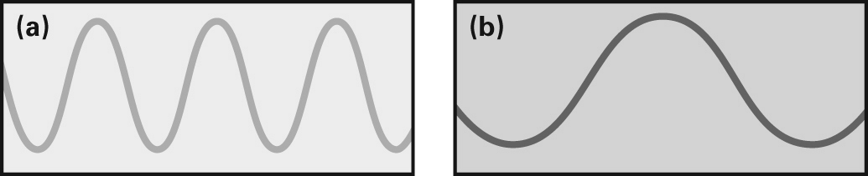

|  |  |
| --- | --- |
| a. | have different wavelengths. |
| b. | have different amplitudes. |
| c. | represent the same hue (color) of light. |
| d. | travel at different velocities. |

ANS: A DIF: Difficult REF: 1.3

OBJ: 1C. Assess the evidence for the expanding Universe and the Big Bang theory.

MSC: Understanding

34. The figure below shows a moving source of light with four stationary observers at different locations. Which observer will see red-shifted light from the moving source?

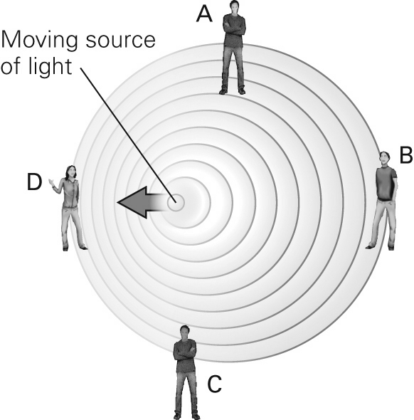

|  |  |  |  |
| --- | --- | --- | --- |
| a. | A | c. | C |
| b. | B | d. | D |

ANS: B DIF: Difficult REF: 1.3

OBJ: 1C. Assess the evidence for the expanding Universe and the Big Bang theory.

MSC: Applying

35. When we say that light from a distant stellar object is red-shifted, this means that the light we see

|  |  |
| --- | --- |
| a. | is from an object moving toward us. |
| b. | is red in color and must have come from a red giant star. |
| c. | has a higher frequency than at the source. |
| d. | has a longer wavelength than at the source. |

ANS: D DIF: Difficult REF: 1.3

OBJ: 1C. Assess the evidence for the expanding Universe and the Big Bang theory.

MSC: Understanding

36. Light from a star that has been shifted due to the Doppler effect is most likely to tell us the __________ of the star.

|  |  |
| --- | --- |
| a. | relative velocity |
| b. | temperature |
| c. | composition |
| d. | age |

ANS: A DIF: Moderate REF: 1.3

OBJ: 1C. Assess the evidence for the expanding Universe and the Big Bang theory.

MSC: Applying

37. Which of the following is true about blue-shifted light that we detect from the cosmos?

|  |  |
| --- | --- |
| a. | It signifies a source that is moving toward us. |
| b. | It is common for galaxies to emit this type of light. |
| c. | The detected light has a longer wavelength than at the source. |
| d. | The detected light has a lower frequency than at the source. |

ANS: A DIF: Difficult REF: 1.3

OBJ: 1C. Assess the evidence for the expanding Universe and the Big Bang theory.

MSC: Understanding

38. The images below show two different nuclear reactions. The left image shows ________, while the right image shows ________.

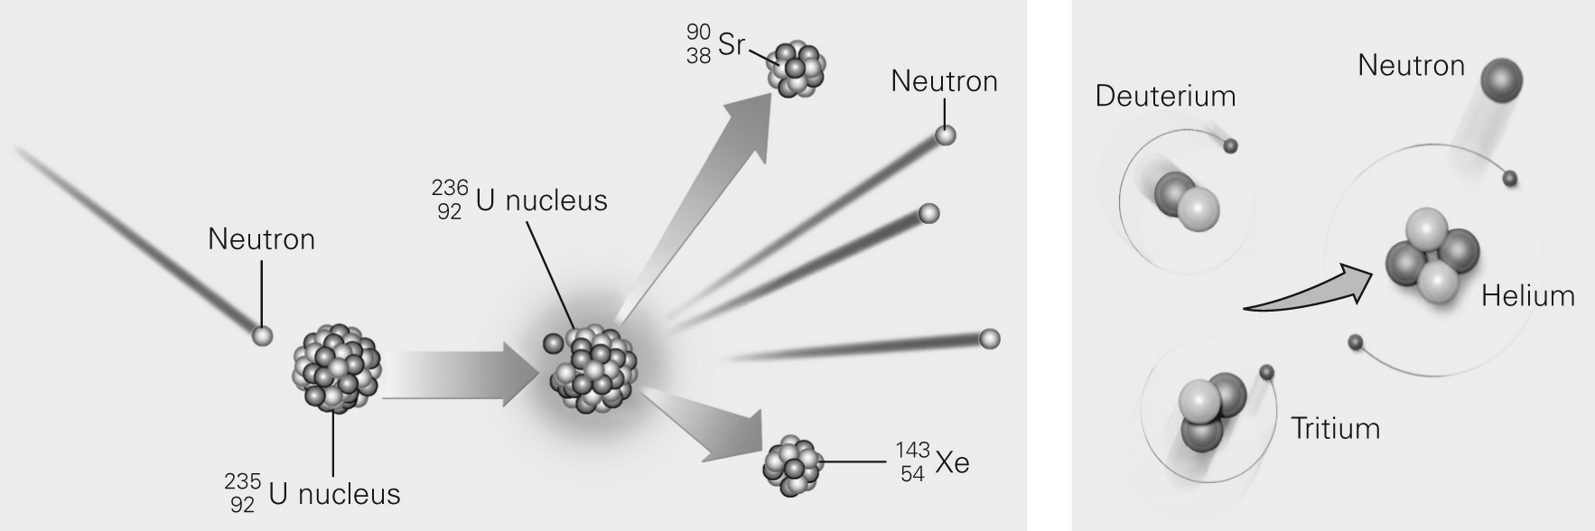

|  |  |
| --- | --- |
| a. | fusion; fission |
| b. | fission; fusion |
| c. | Both images show the same type of fusion. |
| d. | Both images show the same type of fission. |

ANS: B DIF: Difficult REF: 1.3 | Box 1.3

OBJ: 1D. Describe where the elements that make up matter came from.

MSC: Analyzing

39. Atoms that are heavier than iron are generally produced by

|  |  |  |  |
| --- | --- | --- | --- |
| a. | fission reactions within stars. | c. | explosions of supernovas. |
| b. | fusion reactions within stars. | d. | the Big Bang. |

ANS: C DIF: Difficult REF: 1.4

OBJ: 1D. Describe where the elements that make up matter came from.

MSC: Understanding

40. By far the most common elements in the Universe and in our Solar System are

|  |  |  |  |
| --- | --- | --- | --- |
| a. | nitrogen and oxygen. | c. | hydrogen and helium. |
| b. | iron and manganese. | d. | hydrogen and oxygen. |

ANS: C DIF: Easy REF: 1.4

OBJ: 1D. Describe where the elements that make up matter came from.

MSC: Remembering

41. Volatile materials can exist as gases at the Earth’s surface. Which of the following is NOT a volatile material?

|  |  |  |  |
| --- | --- | --- | --- |
| a. | water | c. | hydrogen |
| b. | silicon | d. | carbon dioxide |

ANS: B DIF: Moderate REF: 1.4

OBJ: 1D. Describe where the elements that make up matter came from.

MSC: Applying

42. The primary evidence that our Sun is a third-, fourth-, or fifth-generation star comes from the fact that our

|  |  |
| --- | --- |
| a. | Solar System contains too many heavy atoms to be first-generation. |
| b. | Solar System is too large to be first-generation. |
| c. | Sun is too hot to be a first-generation star. |
| d. | Sun is too large to be a first-generation star. |

ANS: A DIF: Difficult REF: 1.4

OBJ: 1D. Describe where the elements that make up matter came from.

MSC: Applying

43. Which of the following bodies is the smallest?

|  |  |  |  |
| --- | --- | --- | --- |
| a. | planet | c. | protoplanet |
| b. | star | d. | planetesimal |

ANS: D DIF: Moderate REF: 1.4

OBJ: 1E. Explain the nebula theory, a scientific model that explains how stars and planets form.

MSC: Analyzing

44. The current scientific explanation for the origin of planets, moons, asteroids, and comets in our Solar System is the

|  |  |  |  |
| --- | --- | --- | --- |
| a. | expanding Universe theory. | c. | Big Bang theory. |
| b. | nebular theory. | d. | theory of plate tectonics. |

ANS: B DIF: Moderate REF: 1.4

OBJ: 1E. Explain the nebula theory, a scientific model that explains how stars and planets form.

MSC: Analyzing

45. Differentiation of the core from the mantle early in the Earth’s history was possible because the planet was ________ at the time.

|  |  |  |  |
| --- | --- | --- | --- |
| a. | very cold | c. | very small |
| b. | very hot | d. | the only planet in the Solar System |

ANS: B DIF: Moderate REF: 1.4

OBJ: 1E. Explain the nebula theory, a scientific model that explains how stars and planets form.

MSC: Understanding

46. The metal alloy that makes up the core of the Earth is ________, as compared to the rocky mantle.

|  |  |
| --- | --- |
| a. | less dense |
| b. | denser |
| c. | very similar in chemistry and density |
| d. | distinct in chemistry but of very similar density |

ANS: B DIF: Moderate REF: 1.4

OBJ: 1E. Explain the nebula theory, a scientific model that explains how stars and planets form.

MSC: Applying

47. The figure below represents the final stage in the Earth’s formation, which is marked by all of the following EXCEPT

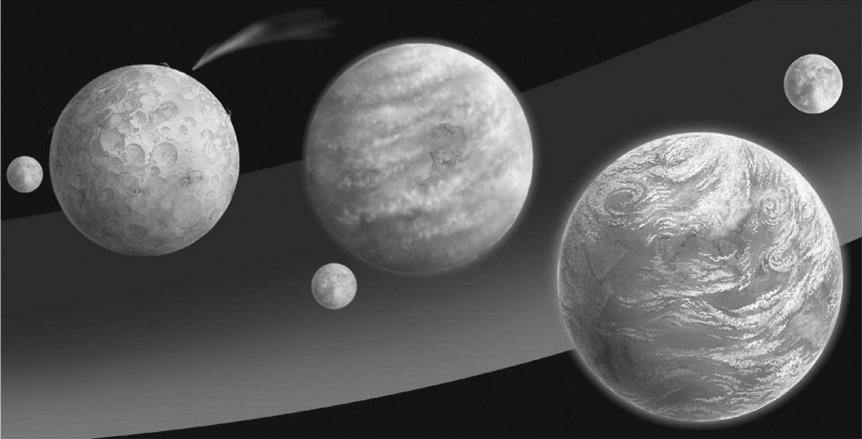

|  |  |
| --- | --- |
| a. | atmosphere formation. |
| b. | rains creating the oceans. |
| c. | gases being added by passing comets. |
| d. | differentiation of the core and mantle. |

ANS: D DIF: Moderate REF: 1.4

OBJ: 1E. Explain the nebula theory, a scientific model that explains how stars and planets form.

MSC: Remembering

48. Scientists believe that the Moon formed due to a protoplanet colliding with the Earth. If this is the case, the Moon should have a composition similar to

|  |  |  |  |
| --- | --- | --- | --- |
| a. | other meteors. | c. | the Earth’s crust. |
| b. | other comets. | d. | the Earth’s mantle. |

ANS: D DIF: Difficult REF: 1.4

OBJ: 1E. Explain the nebula theory, a scientific model that explains how stars and planets form.

MSC: Evaluating

49. Currently, the most accurate ages of the Earth come from dating

|  |  |
| --- | --- |
| a. | ice in comets. |
| b. | ancient volcanic rocks. |
| c. | rock samples brought back from the Moon. |
| d. | meteorites. |

ANS: D DIF: Moderate REF: 1.4

OBJ: 1E. Explain the nebula theory, a scientific model that explains how stars and planets form.

MSC: Applying

50. Which of the following best describes how the Earth’s Moon formed?

|  |  |
| --- | --- |
| a. | The Earth and Moon formed at the same time. |
| b. | Early in the history of our Solar System, an asteroid was captured by the Earth’s gravity and became the Moon. |
| c. | Early in the history of our Solar System, a protoplanet collided with the Earth, sending debris into orbit that coalesced to form the Moon. |
| d. | Early in the history of our Solar System, a group of comets was captured by the Earth’s gravity and coalesced to form the Moon. |

ANS: C DIF: Moderate REF: 1.4

OBJ: 1E. Explain the nebula theory, a scientific model that explains how stars and planets form.

MSC: Analyzing

**SHORT ANSWER**

1. In the context of scientific cosmology, the universe contains two basic entities. Define these entities and explain the difference between them.

ANS:

The Universe contains matter and energy. Matter is the substance that makes up objects. Energy is the inherent ability of a region of space and the matter within it to do “work”—to change itself or its surroundings.

DIF: Difficult REF: 1.1

OBJ: 1B. Explain modern concepts concerning the basic architecture of our Universe and its components. MSC: Applying

2. The following images of a geocentric universe and a heliocentric universe were drawn by artists hundreds of years ago. Contrast these two views of the universe.

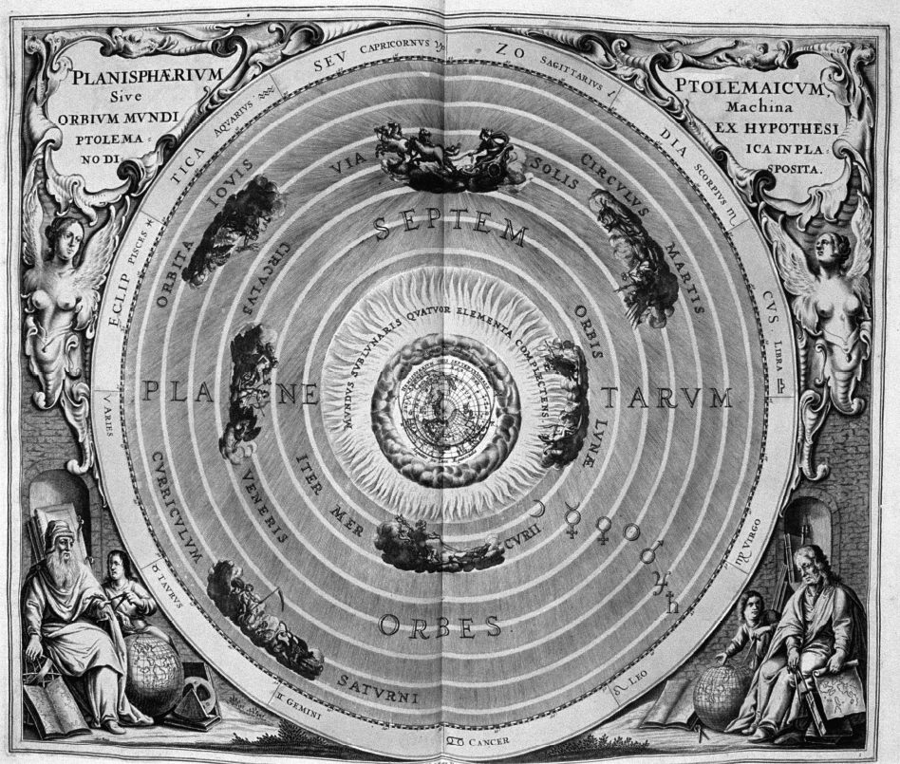 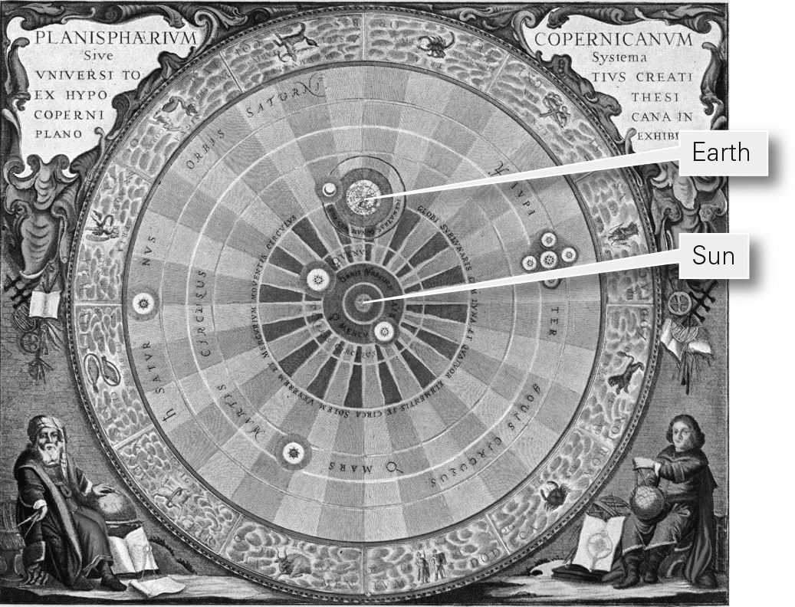

ANS:

In a geocentric model, the Earth sits without moving at the center of the Universe while the Moon and the planets orbit it in a circular pattern. In a heliocentric model, the Sun sits at the center of the Universe with the Earth and other planets orbiting around it.

DIF: Easy REF: 1.2

OBJ: 1A. Assess how people’s perceptions of the Earth’s place in the Universe have changed over the centuries. MSC: Applying

3. What is a planet? List the three criteria that define a planet. Why is Pluto no longer considered a planet?

ANS:

A planet is an object that orbits a star, is roughly spherical, and has cleared its neighborhood of other objects. Pluto is not a planet because it has not cleared its orbit.

DIF: Moderate REF: 1.2

OBJ: 1B. Explain modern concepts concerning the basic architecture of our Universe and its components. MSC: Applying

4. Contrast the terrestrial planets and the giant planets.

ANS:

The terrestrial planets are the four inner planets, the ones closest to the Sun. They, like the Earth, consist of a shell of rock surrounding a ball of metal. The giant planets are the four outer planets. They are much more massive than the terrestrial planets, and their overall composition differs markedly—they are rich in gas and ice.

DIF: Moderate REF: 1.2

OBJ: 1B. Explain modern concepts concerning the basic architecture of our Universe and its components. MSC: Applying

5. What is happening to the size of the Universe? How do we know?

ANS:

The Universe is expanding. Most of the light coming to the Earth from distant galaxies displays a red shift, which is a consequence of the Doppler effect. Red-shifted light is the result of galaxies moving away from the Earth.

DIF: Difficult REF: 1.3

OBJ: 1C. Assess the evidence for the expanding Universe and the Big Bang theory.

MSC: Applying

6. Scientists have estimated the age of the Earth to be 4.57 Ga. What did they use to determine this age and why did they use it?

ANS:

The age of the Earth was determined by radiometric age dating of meteorites. Rocks from the Earth have been recycled so much that we no longer have any rocks that date back to the formation of the Earth. However, since everything in the Solar System was created at the same time, and meteorites have not been recycled since their formation, meteorite samples were used to determine the age of the Solar System.

DIF: Moderate REF: 1.4

OBJ: 1B. Explain modern concepts concerning the basic architecture of our Universe and its components. MSC: Applying

7. The first atoms of the Universe (hydrogen and helium) formed within minutes of the Big Bang. How did the other elements form?

ANS:

Heavier elements form during fusion reactions in stars, and the heaviest are mostly made during supernova explosions. Elements up to iron, atomic number 26, form during the process of stellar nucleosynthesis. Elements with atomic numbers greater than that of iron form in the ultra-high temperatures that develop during supernova explosions during supernova nucleosynthesis.

DIF: Moderate REF: 1.4

OBJ: 1D. Describe where the elements that make up matter came from.

MSC: Applying

8. Briefly describe how our Solar System formed, according to the nebular theory.

ANS:

Our Solar System formed from a nebular cloud of gas and dust that flattened into an accretionary disk under the influence of gravity. The Sun formed at the center of this disk, and the planets formed via accretion of materials in the rings surrounding the protosun.

DIF: Moderate REF: 1.4

OBJ: 1E. Explain the nebula theory, a scientific model that explains how stars and planets form.

MSC: Applying

9. Why is the Earth round?

ANS:

Early in the Earth’s history, it became large enough for its interior to become warm and soft. This allowed the force of gravity to make it flow. When this happened, the low places rose and the high places sank until the Earth was nearly a sphere whose mass was evenly distributed such that the force of gravity was about the same at all points on the surface.

DIF: Moderate REF: 1.4

OBJ: 1E. Explain the nebula theory, a scientific model that explains how stars and planets form.

MSC: Applying

10. How did our Moon form?

ANS:

Soon after the Earth formed, a protoplanet collided with it. Debris from the collision formed a ring around the Earth, and the Moon formed from this debris.

DIF: Easy REF: 1.4

OBJ: 1E. Explain the nebula theory, a scientific model that explains how stars and planets form.

MSC: Applying